
Symbiosis Institute of Technology, Pune
CSE- Academic Year 2026-27
Java Programming – Lab Batch 2025-29
Lab Assignment No.: 20
Name of Student | Akshit Gawade
PRN No. | 25070122029
Batch | 2025-2029
Class | A1
Academic Year & Semester | Second Year  Semester III
Date of Submission
Title of Assignment: | Develop a Java application to establish connectivity with a database and perform INSERT, UPDATE, and DELETE operations
Problem Statement  &  Learning  Objective | Problem Statement  Develop a Java application to establish connectivity with a database and perform INSERT,  UPDATE, and DELETE operations.  Learning Objectives  To perform database modification operations using JDBC.
Theory | JDBC allows Java applications to perform database manipulation using SQL Data Manipulation Language (DML) statements such as INSERT, UPDATE, and DELETE. The INSERT statement adds new records into database tables, UPDATE modifies existing records, and DELETE removes unwanted records. These operations are executed using the Statement or PreparedStatement interface. PreparedStatement is generally preferred because it supports parameterized queries, improves performance, and prevents SQL injection attacks. Proper transaction management ensures  that database modifications are performed safely and consistently. These operations form the basis of almost every database-driven application such as banking systems, hospital management systems, and student information systems.
Program Code | import java.sql.*;  public class Main {  public static void main(String[] args) {  try {  Class.forName("com.mysql.cj.jdbc.Driver");  Connection con = DriverManager.getConnection(  "jdbc:mysql://localhost:3306/college2",  "root",  "P@resh123!"  );  Statement stmt = con.createStatement();  // INSERT  stmt.executeUpdate(  "INSERT INTO student VALUES (426, 'Akshit', 'Cyber Security', 78)"  );  System.out.println("Record inserted successfully.");  // UPDATE  stmt.executeUpdate(  "UPDATE student SET marks = 86 WHERE roll_no = 426"  );  System.out.println("Record updated successfully.");  // DELETE  stmt.executeUpdate(  "DELETE FROM student WHERE roll_no = 426"  );  System.out.println("Record deleted successfully.");  con.close();  }  catch (Exception e) {  System.out.println("Error: " + e.getMessage());  }  }  }
Output Screenshots | 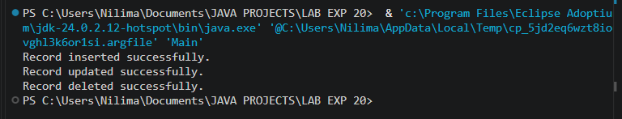
Exercise Qns  and Code | - Create a Java application to manage employee records using CRUD operations.  import java.sql.*;  public class Exp1 {  public static void main(String[] args) {  try {  Class.forName("com.mysql.cj.jdbc.Driver");  Connection con = DriverManager.getConnection(  "jdbc:mysql://localhost:3306/company2",  "root",  "P@resh123!"  );  Statement stmt = con.createStatement();  // CREATE - Insert employee  stmt.executeUpdate(  "INSERT INTO employee VALUES (247, 'Akshit', 'Finance', 68500)"  );  System.out.println("Employee inserted successfully.");  // UPDATE - Update salary  stmt.executeUpdate(  "UPDATE employee SET salary = 73200 WHERE emp_id = 247"  );  System.out.println("Employee updated successfully.");  // READ - Display employee  ResultSet rs = stmt.executeQuery(  "SELECT * FROM employee"  );  System.out.println("\nEmployee Records:");  while (rs.next()) {  System.out.println(  "ID: " + rs.getInt("emp_id") +  ", Name: " + rs.getString("name") +  ", Department: " + rs.getString("department") +  ", Salary: " + rs.getDouble("salary")  );  }  // DELETE - Delete employee  stmt.executeUpdate(  "DELETE FROM employee WHERE emp_id = 247"  );  System.out.println("Employee deleted successfully.");  con.close();  }  catch (Exception e) {  System.out.println("Error: " + e.getMessage());  }  }  }  2. Create a Java application to manage student records using CRUD operations. Perform Create, Read, Update, and Delete operations on student details such as roll number, name, course, and marks using a database.  import java.sql.*;  public class Exp2 {  public static void main(String[] args) {  try {  Class.forName("com.mysql.cj.jdbc.Driver");  Connection con = DriverManager.getConnection(  "jdbc:mysql://localhost:3306/college2",  "root",  "P@resh123!"  );  Statement stmt = con.createStatement();  // CREATE - Insert student  stmt.executeUpdate(  "INSERT INTO student VALUES (318, 'Akshit', 'Data Science', 87)"  );  System.out.println("Student inserted successfully.");  // UPDATE - Update marks  stmt.executeUpdate(  "UPDATE student SET marks = 93 WHERE roll_no = 318"  );  System.out.println("Student updated successfully.");  // READ - Display students  ResultSet rs = stmt.executeQuery(  "SELECT * FROM student"  );  System.out.println("\nStudent Records:");  while (rs.next()) {  System.out.println(  "Roll No: " + rs.getInt("roll_no") +  ", Name: " + rs.getString("name") +  ", Course: " + rs.getString("course") +  ", Marks: " + rs.getInt("marks")  );  }  // DELETE - Delete student  stmt.executeUpdate(  "DELETE FROM student WHERE roll_no = 318"  );  System.out.println("Student deleted successfully.");  con.close();  }  catch (Exception e) {  System.out.println("Error: " + e.getMessage());  }  }  }
Output Screenshots | Exp1:  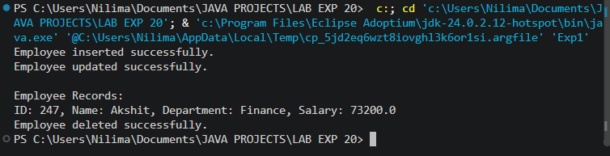  Exp2:  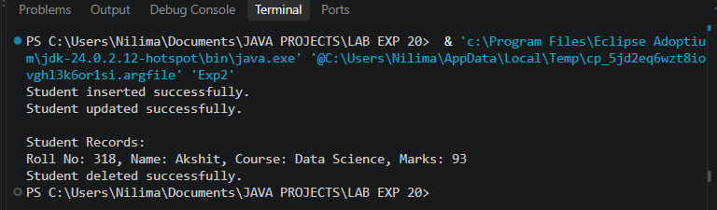
Conclusion | This experiment completes relational database management using PreparedStatement for Data Manipulation Language tasks. It highlights executing parameter-bound SQL queries via executeUpdate() to maintain dynamic application data securely, preventing SQL injection vulnerabilities while managing database transaction outcomes.

